Steps Project

DUE Sunday, March 27, 2022 by 11:59 pm

1. Get the Steps Spreadsheet. Put the data in one sheet marketed “data” and each table and graph in their own separate sheet. You will then have four sheets in your workbook- one for the data and one for each table/graph. The screen shots show you the required formatting of the tables. All data should come from the data sheet and not be on any of the table/graph sheets.
2. Clean your data. Make sure it is valid, reasonable, and correct.
3. Produce the following table using statistical functions:

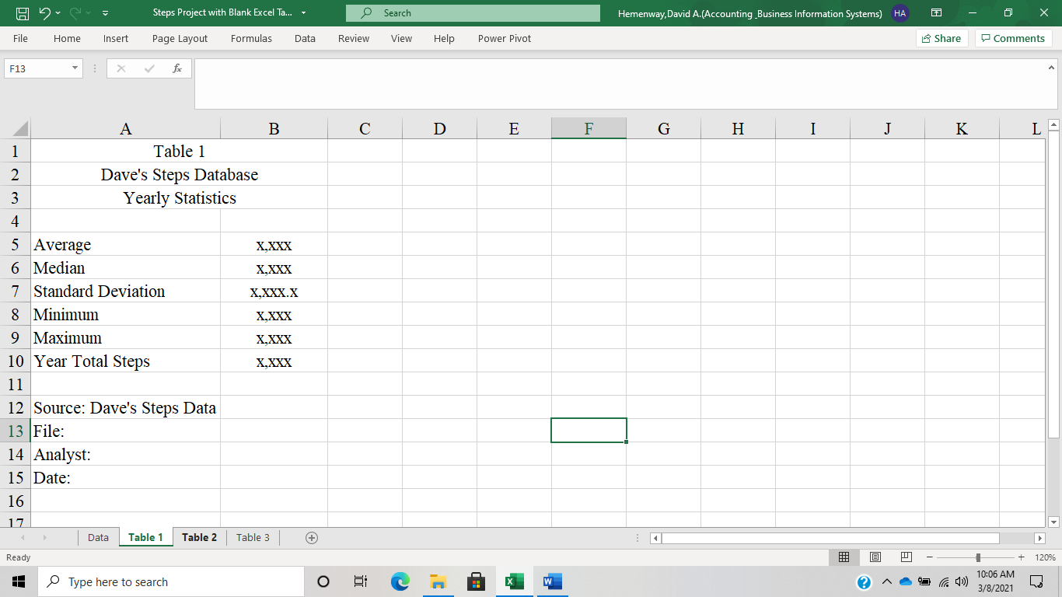

|  |  |
| --- | --- |
|  | |
|  | |
|  | |
|  |  |
|  |  |
|  |  |
|  | |
|  |  |
|  |  |
|  |  |
|  | |

1. Produce the following table using the most appropriate IF statements/functions and statistical functions:  
     
   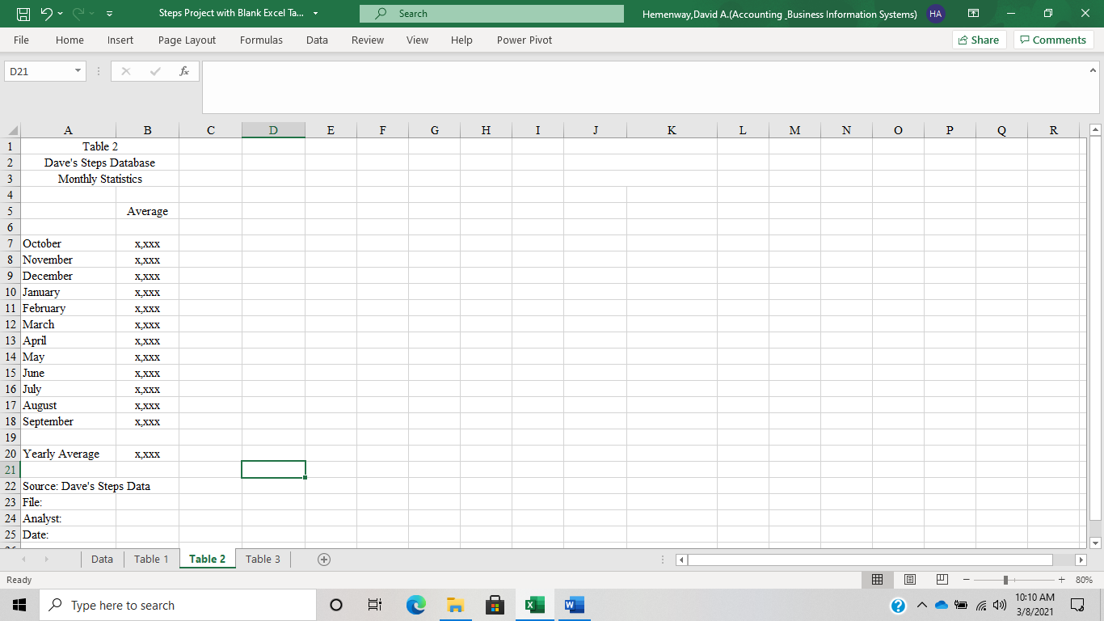

|  |
| --- |
|  |

1. Produce a bar chart of this information. Do NOT include Yearly Average in this chart. Charts must include title, axis titles, and data labels.

|  |
| --- |
|  |

5. Produce the following table using the most appropriate IF statements/functions and statistical functions:

|  |  |
| --- | --- |
|  | |
|  | |
| 1. Produce a bar chart of this information. Do not include Yearly Average in your bar chart. Charts must include title, axis titles, and data labels. | |
|  | |
|  |  |
|  |  |
|  |  |
|  |  |
|  |  |
|  |  |
|  |  |
|  |  |
|  |  |
|  |  |
|  |  |
|  |  |
|  |  |
|  |  |
|  | |